CLOUD WATCH && CLOUD TRAIL
- Enable CloudTrail monitoring and store the events in S3 and CloudWatch log events.

Objective :
The objective of this task is to enable AWS CloudTrail monitoring and configure it to deliver audit events to both:
- Amazon S3 — for long-term storage and auditing.
- Amazon CloudWatch Logs — for real-time monitoring, searching, and creating alarms.

Architecture :
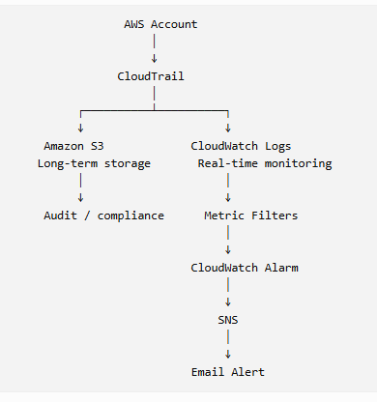
Prerequisites :
Before starting, you should have:
AWS account
An active AWS account.
- IAM permissions
- You need sufficient permissions to:
- Create/manage CloudTrail trails
- Create/manage S3 buckets
- Create/manage CloudWatch log groups
- Configure IAM roles
- View CloudTrail events
- For a lab environment, an administrator-level IAM identity can simplify setup. In production, use least-privilege permissions.
- S3 bucket
You can create a new S3 bucket specifically for CloudTrail logs.
- The bucket name must be globally unique.
Example:
swaroop-cloudtrail-logs-2026
- CloudWatch Log Group
You can create one specifically for CloudTrail.
Example: /aws/cloudtrail/management-events

Step-by-Step Implementation :

Step 1: Create an S3 Bucket
Go to:
AWS Console → S3 → Create bucket

Enter a unique bucket name :
aws-cloudtrail-logs-560151615745-78df7d67
click :
create bucket

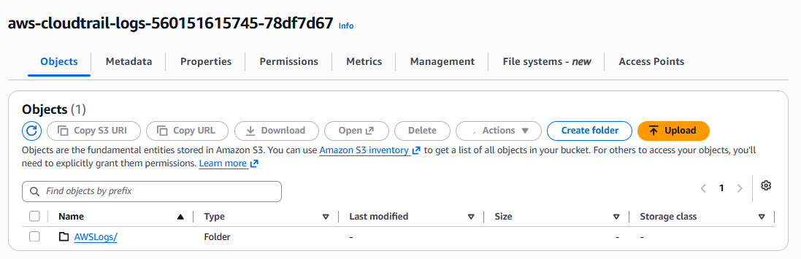

Step 2: Open CloudTrail
Go to:
AWS Console → CloudTrail
You should see the CloudTrail dashboard.
Select:
Trails
Then click:
Create trail

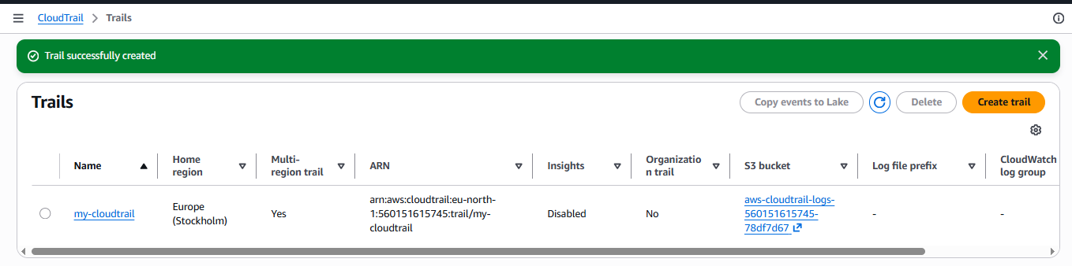

Step 3: Enter Trail Name
Enter tail name :
my-cloudtrail

Step 4: Configure Management Events
Management events record control-plane operations such as:
Create
Modify
Delete
Start
Stop
Describe
Management events → Read and Write events
This gives you both :
Read events + Write events

Step 5: Configure S3 Storage
Under the S3 section, select:
Create new S3 bucket
or
select the bucket you created earlier.
Bucket name :
aws-cloudtrail-logs-560151615745-78df7d67

Step 6: Configure CloudWatch Logs
In the CloudWatch Logs section, enable delivery to CloudWatch Logs.
Enter/create a log group such as:
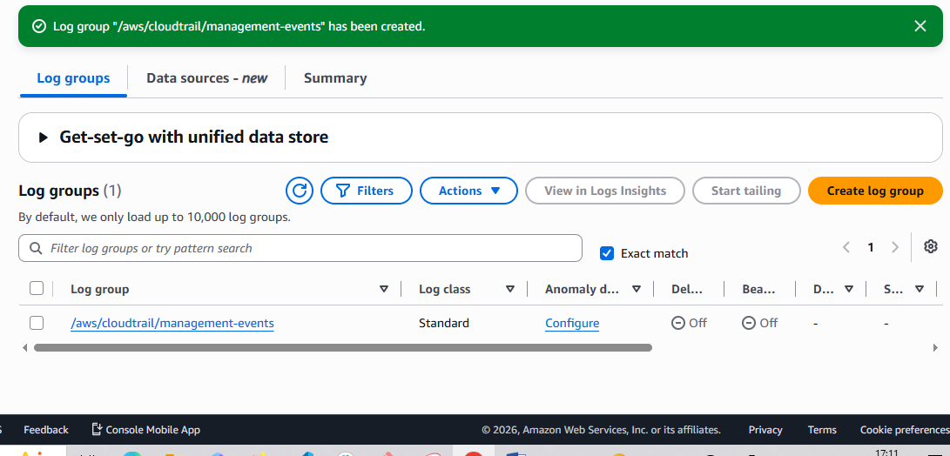

- Enable SNS for CloudTrail to send alerts via email.

Objective :
Configure AWS so that when a selected CloudTrail event occurs, an SNS notification is sent to an email address.

Prerequisites :
- AWS account
- CloudTrail enabled
- CloudWatch Logs configured for CloudTrail
- Email address that you can access
- IAM permissions to create SNS topics/subscriptions and CloudWatch/EventBridge rules

Step 1: Create an SNS Topic
- Open the AWS Management Console.
- Search for SNS.
- Select Amazon Simple Notification Service.
- Go to Topics.
- Click Create topic.
- Select Standard.
- Enter a name, for example:
cloudtrail-alerts
- Click Create topic.
You now have an SNS topic that will act as the notification channel.
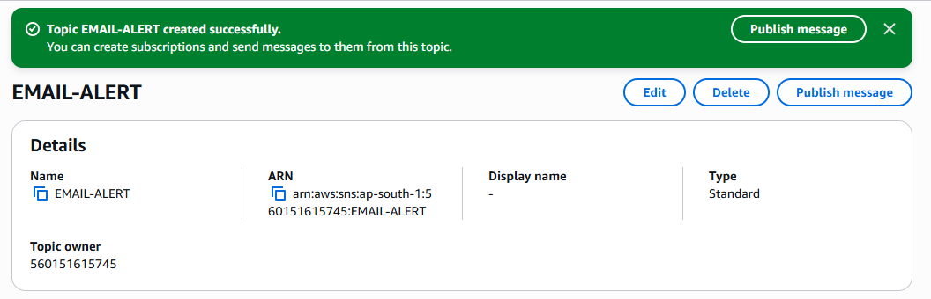

Step 2: Create an Email Subscription
- Open your cloudtrail-alerts topic.
- Click Create subscription.
- For Protocol, select:
Email
- For Endpoint, enter your email address.
- Click Create subscription.
SNS will send a confirmation email to that address.
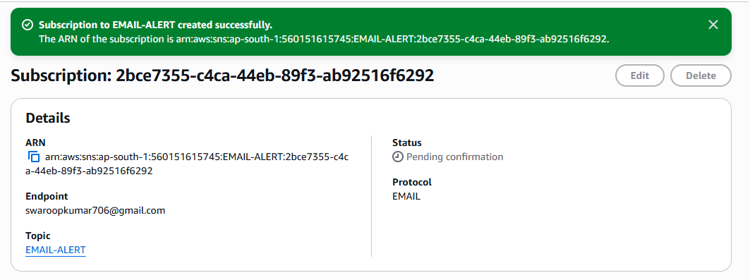

Step 3: Confirm the Subscription
Open your email inbox and look for an AWS SNS subscription confirmation email.
Click:
Confirm subscription
After confirmation, the SNS subscription status should become:
Confirmed
If you don't confirm it, SNS will not deliver notifications to that email address.

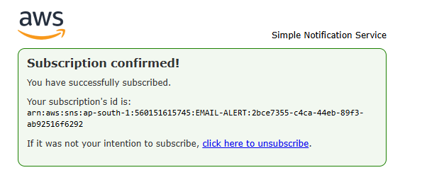

Step 4: Configure CloudTrail to Send Events to CloudWatch Logs
Go to:
CloudTrail → Trails → Your Trail
Under CloudWatch Logs, configure:
- Send to CloudWatch Logs: Enabled
- Log group: Create/select a CloudWatch log group
- IAM role: Select/create the required CloudTrail CloudWatch Logs role
For example:
/aws/cloudtrail/logs
CloudTrail events will now be available in CloudWatch Logs.

Step 4: Configure CloudTrail to Send Events to CloudWatch Logs
Go to:
CloudTrail → Trails → Your Trail
Under CloudWatch Logs, configure:
- Send to CloudWatch Logs: Enabled
- Log group: Create/select a CloudWatch log group
- IAM role: Select/create the required CloudTrail CloudWatch Logs role
For example:
/aws/cloudtrail/logs
CloudTrail events will now be available in CloudWatch Logs.

Step 5: Create a CloudWatch Metric Filter
Suppose you want an alert when someone performs a sensitive IAM action.
Go to:
CloudWatch → Log groups → /aws/cloudtrail/logs
Create a Metric filter.
For example, you could filter for root-user activity:
{ $.userIdentity.type = "Root" && $.eventType != "AwsServiceEvent" }
Then configure:
Metric namespace:
CloudTrailMetrics
Metric name:
RootUserActivity
Metric value:
1

Step 6: Create a CloudWatch Alarm
Go to:
CloudWatch → Alarms → Create alarm
Select the metric:
CloudTrailMetrics
→ RootUserActivity
Configure the condition, for example:
Statistic: Sum
Period: 5 minutes
Threshold: >= 1
This means:
If at least one matching CloudTrail event occurs within 5 minutes, trigger the alarm.

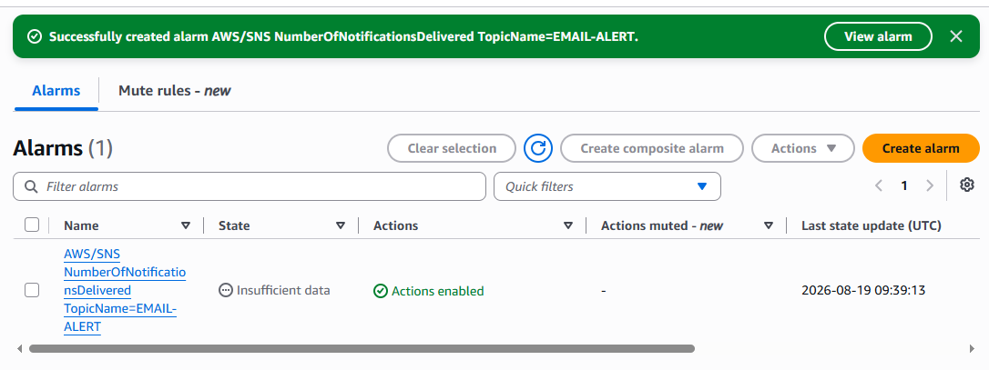

Step 7: Configure SNS as the Alarm Action
Under Notification, select:
In alarm
Choose your SNS topic:
cloudtrail-alerts
Then create the alarm.
Flow will be :

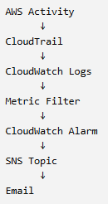

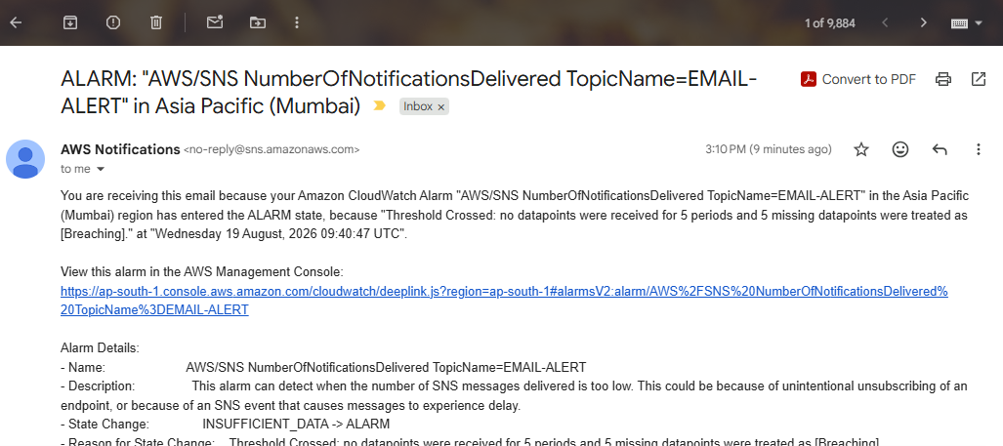

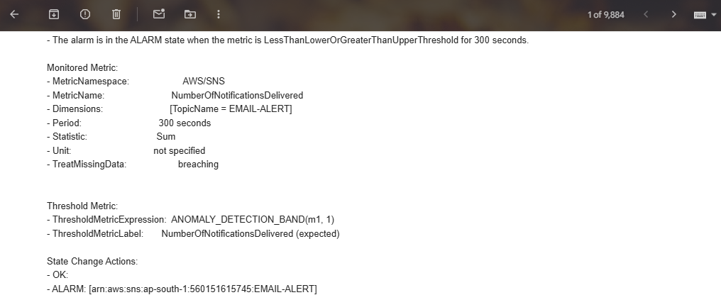
3. Configure CloudWatch monitoring and record the CPU utilization and other metrics of
EC2.

Objective
To configure Amazon CloudWatch to monitor an EC2 instance and record important performance metrics such as:
- CPU utilization
- Network traffic
- Network packets
- EC2 status checks
- EBS-related metrics

Prerequisites
Before starting, make sure you have:
- An EC2 instance in the Running state.
- Access to the AWS Management Console.
- IAM permissions to view CloudWatch and EC2 metrics.
- A running EC2 instance that generates monitoring data.

Step 1: Open EC2
- Log in to the AWS Management Console.
- Go to EC2.
- Select Instances.
- Select the EC2 instance that you want to monitor.

Step 2: Check EC2 Monitoring
Select your instance and open the Monitoring tab.
You should see graphs such as:
- CPU Utilization
- Network In
- Network Out
- Network Packets In
- Network Packets Out
- Status Check Failed
30–60% | Normal/moderate

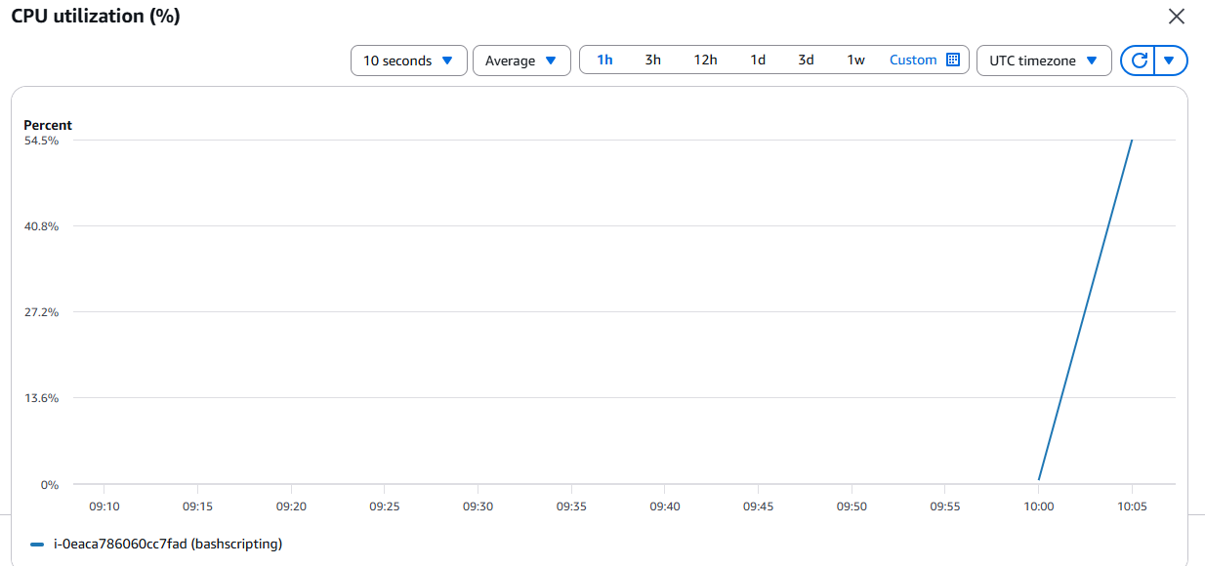
CPU UTILISATION :
60–80% | High

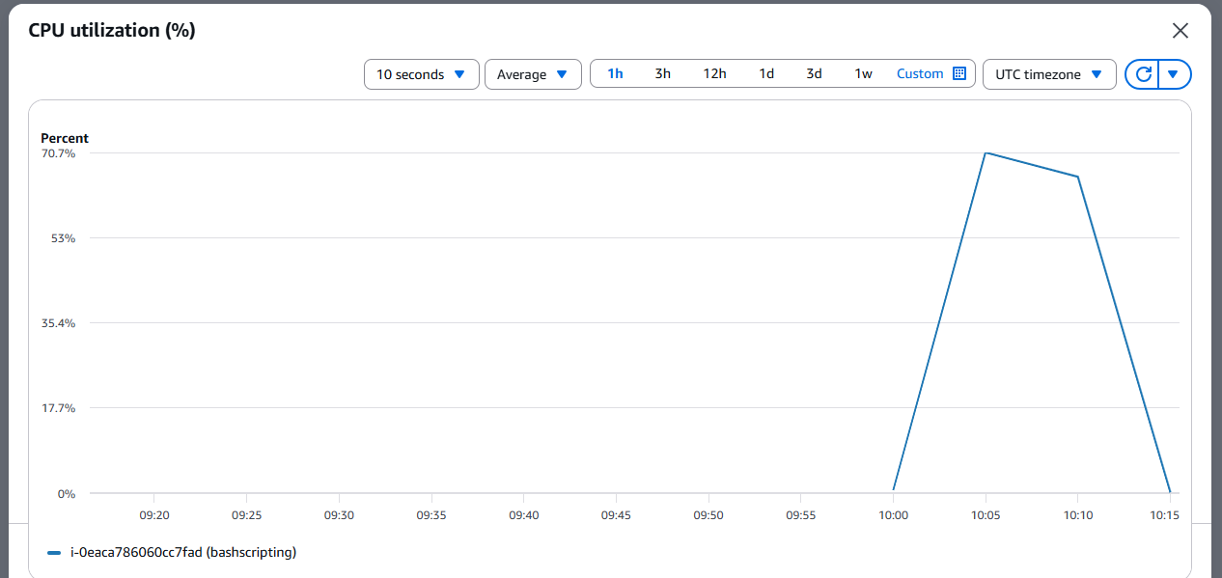
CPU Utilization | Interpretation

0–30% | Low usage

30–60% | Normal/moderate

60–80% | High

80–100% | Very high

- Create one alarm to send an alert to email if the CPU utilization is more than 70 percent.

Objective :
The objective of this task is to create an Amazon CloudWatch alarm that continuously monitors the CPU utilization of an EC2 instance and triggers an alert when CPU usage exceeds 70%.

Prerequisites
You should already have:
- An EC2 instance running
- CloudWatch monitoring enabled
- An SNS topic, for example cloudtrail-alerts
- Your email subscription confirmed in SNS

Expected Flow
EC2 → CloudWatch CPUUtilization → Alarm (>70%) → SNS → Email Notification

Step 1: Open CloudWatch
- Sign in to AWS Console.
- Go to CloudWatch.
- Select Alarms from the left menu.
- Click Create alarm.
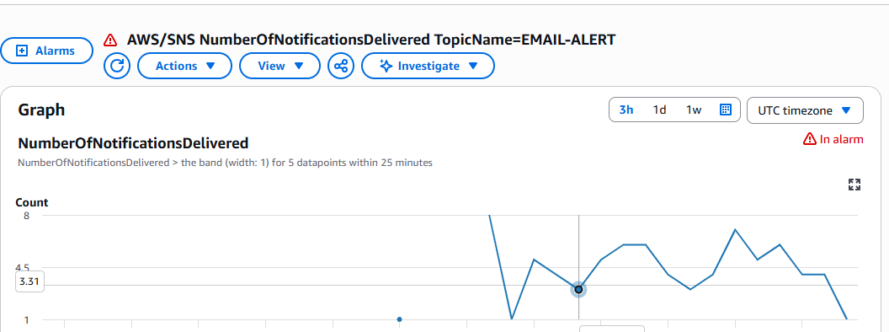

Step 2: Select the EC2 CPU Metric
Click:
Select metric → EC2 → Per-Instance Metrics
Find your EC2 instance and select:
CPUUtilization
Then click Select metric.

Step 3: Configure the Threshold
Under Specify metric and conditions:
Statistic:
Average
Period:
5 minutes
Under Conditions:
Threshold type: Static
Whenever CPUUtilization is... Greater
than 70
So your condition is:
CPUUtilization > 70%

CPU UTILISATION : 100% REACHED
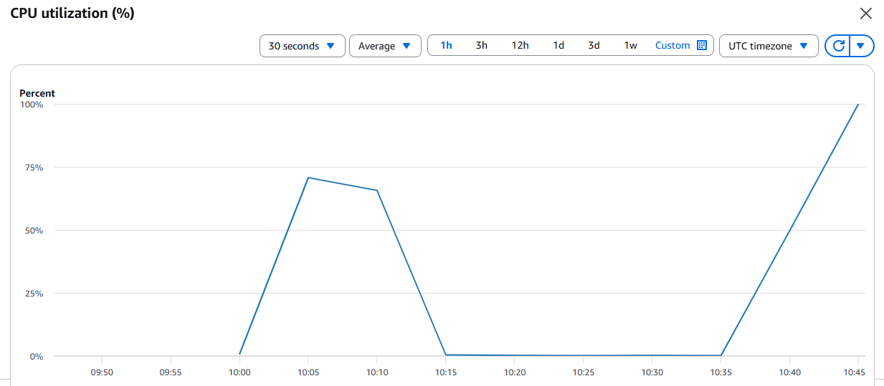

Step 4: Configure the SNS Email Notification
Under Notification:
For Alarm state trigger, select:
In alarm
For Send a notification to the following SNS topic, select your SNS topic
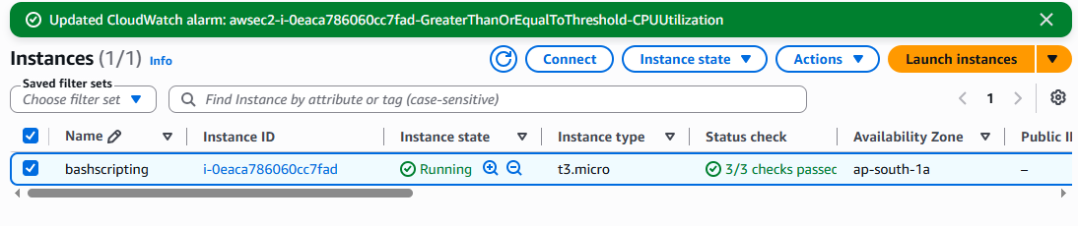
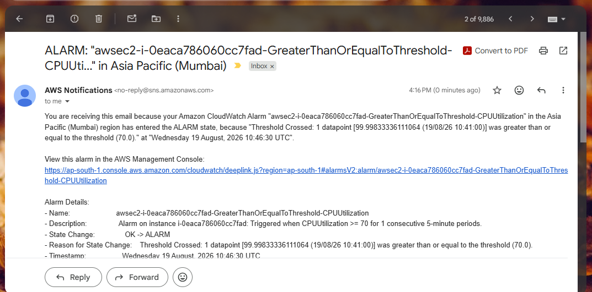
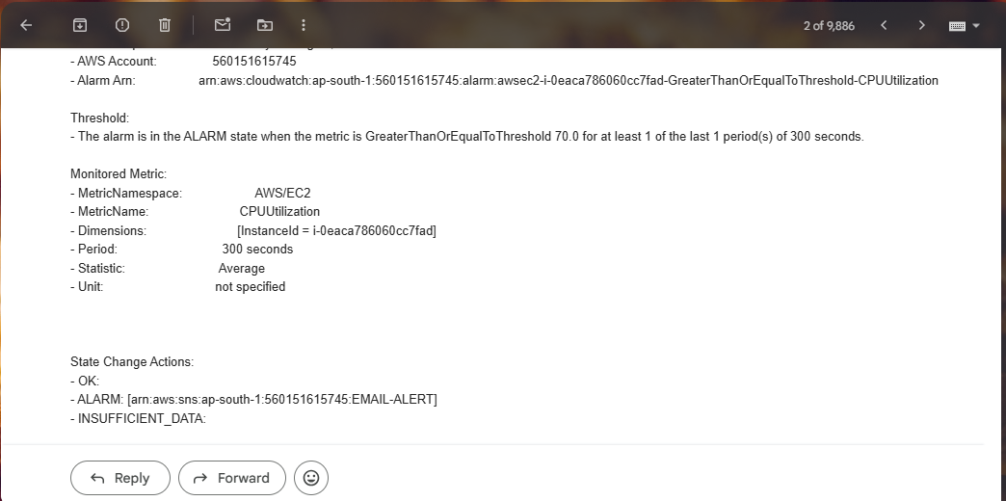
5. Create a Dashboard and monitor the Tomcat service whether it is running or not and
send the alert.

Objective :
Create a CloudWatch Dashboard to monitor the Tomcat service and configure an alarm that sends an email notification through SNS when Tomcat is not running.

Prerequisites — Tomcat Monitoring Dashboard & Alerts
Before creating a CloudWatch Dashboard to monitor whether Tomcat is running and send an alert when it stops, you need the following:

1. AWS Account
2. EC2 Instance
3. Tomcat Must Run as a Systemd Service
4. CloudWatch Agent
5. IAM Role for EC2
6. SNS Topic
7. CloudWatch Permissions
8. Decide What "Tomcat Down" Means
9. Monitoring Method

step 1: Create a Tomcat monitoring script

SSH into your EC2 instance and create:
sudo vi /usr/local/bin/tomcat-monitor.sh

#!/bin/bash

if systemctl is-active --quiet tomcat; then
STATUS=1
else
STATUS=0
fi

aws cloudwatch put-metric-data \
--namespace "Custom/Tomcat" \
--metric-name "TomcatServiceStatus" \
--dimensions InstanceId=$(curl -s http://169.254.169.254/latest/meta-data/instance-id) \
--value $STATUS \
--unit Count

Make it executable :
sudo chmod +x /usr/local/bin/tomcat-monitor.sh
The script checks:
systemctl is-active --quiet tomcat

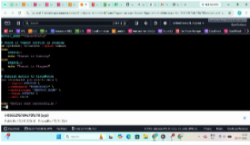

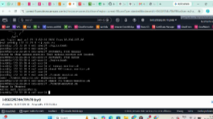

Step 2: Give EC2 permission to send metrics
The EC2 instance needs permission to call:
cloudwatch:PutMetricData
Create/attach an IAM role to the EC2 instance with a policy that allows CloudWatch metric publishing.
A commonly used AWS managed policy for the CloudWatch Agent is:
CloudWatchAgentServerPolicy
Attach this role to your EC2 instance.

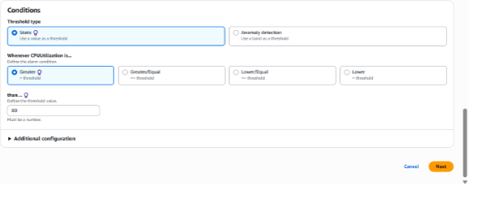

Step 3: Test the script
Run:
sudo /usr/local/bin/tomcat-monitor.sh
Check whether it executes successfully.
You can verify the metric from:
CloudWatch → Metrics → All metrics → Custom namespaces → Custom/Tomcat
You should find:
TomcatServiceStatus
with your EC2 instance as the dimension.
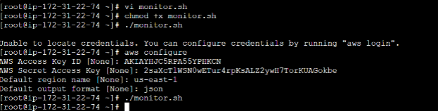

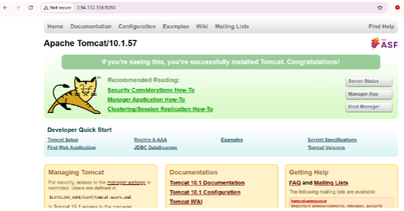

Step 4: Run the check automatically
You want the script to check Tomcat periodically.
Open cron:
sudo crontab -e
Add:
*/1 * * * * /usr/local/bin/tomcat-monitor.sh
This runs the script every minute.
So the architecture becomes:

Every 1 minute
↓
tomcat-monitor.sh
↓
systemctl is-active tomcat
↓
┌───────────────┐
│ Running │ → 1
│ Not running │ → 0
└───────────────┘
↓
CloudWatch

Step 5: Create the CloudWatch Alarm
Go to:
CloudWatch → Alarms → Create alarm
Click:
Select metric
Go to:
Custom namespaces → Custom/Tomcat
Select:
TomcatServiceStatus
Choose your EC2 instance.
Configure:
Statistic: Minimum
Period: 1 minute
For the condition, configure:
Threshold type: Static
TomcatServiceStatus: Lower than
Threshold: 1
This means:
Tomcat = 1
↓
Running
↓
OK

Tomcat = 0
↓
Not running
↓
ALARM

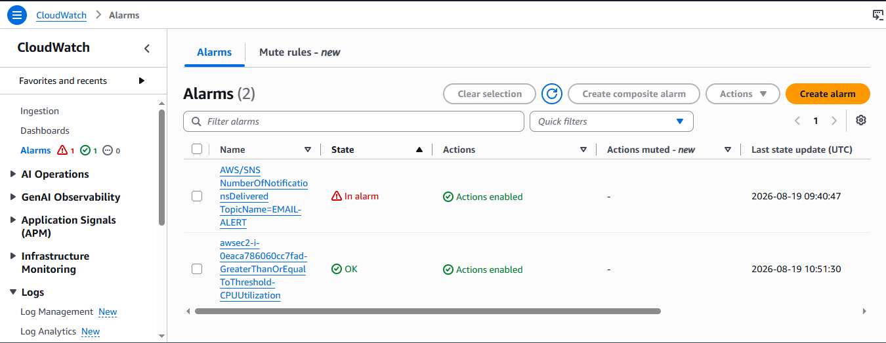
Step 6: create a Dashboard for Tomcat
Dashboard -> create dashboard -> tomcat
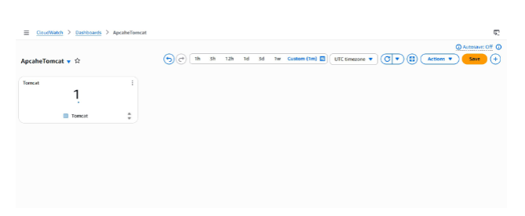

6. Create a Dashboard and monitor the Nginx service to send the alert if Nginx is not
running.
Objective :
To extend application-level health monitoring to the web/reverse-proxy tier, so a stopped Nginx process is caught with the same speed and reliability as a stopped Tomcat process.
Prerequisites :
• CloudWatch Agent installed (Task 3) with the procstat plugin available.
• Nginx installed and running on the instance
Step-by-Step Implementation
Step 1: install nginx and run Nginx
Yum install nginx
Systemctl start nginx
Systemctl enable nginx
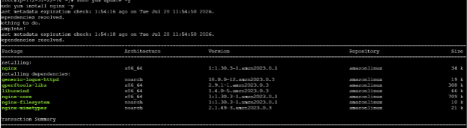
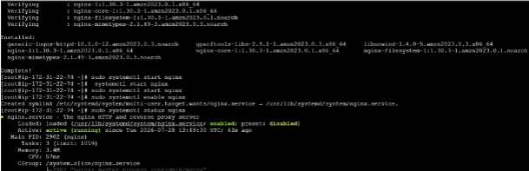
Step 2: create Script file and Exceuted the Script
• Vi monitor.sh - > ./monitor.sh
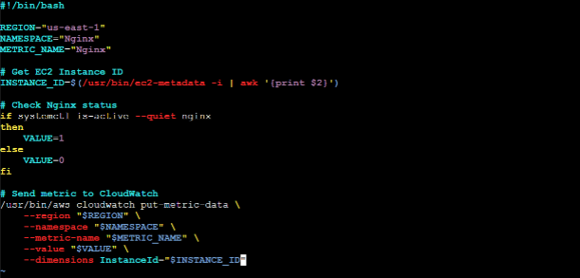

Step 4: create a Dashboard for nginx
Dashboard -> create dashboard -> nginx

